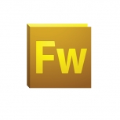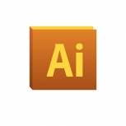

**VS**

Adobe Fireworks versus Adobe Illustrator

**David Gray**

**Student number: x13467362**

For my introduction to multimedia project I have chosen to research and compare the two Adobe graphics editing programmes; Fireworks CS5 versus Illustrator CS5. These are graphic editing programmes used in modern media for web design and advertising. In the fast changing digital world of marketing business and individuals rely heavily on these graphical media mediums. The importance of graphical media today is something I think we barely even notice. We as people see advertisements, applications and videos through some sort of graphical interface constantly so the importance of having good graphic editors available is something Adobe really have worked hard to give us. I will briefly describe both programmes now.

**Adobe Fireworks Cs5:**

Adobe Fireworks was released in 2010 a follow up to other previous versions of the programme (Cs5 is v.11). Adobe recently said that they would be phasing out Fireworks in May 2013 but it will still be used throughout the graphical media world I think. Its unique abilities, easy to use tools and neat layout make it an ideal programme to work with for any type of graphic design. In technical terms Fireworks is a vector editor with bitmap editing capabilities. Its main purpose is for creating graphics for web and screen. The file format that it uses is PNG (FWPNG or PNG), although, this file type is not supported in other adobe products. Other file types fireworks can work with include .GIF, .SWF, .JPG and .PDF. I found fireworks a lot easier to learn than other graphic editing software I have used and it can produce far more complex vector designs. The layout is basic to understand once you learn it and it looks nice which in my opinion is essential.

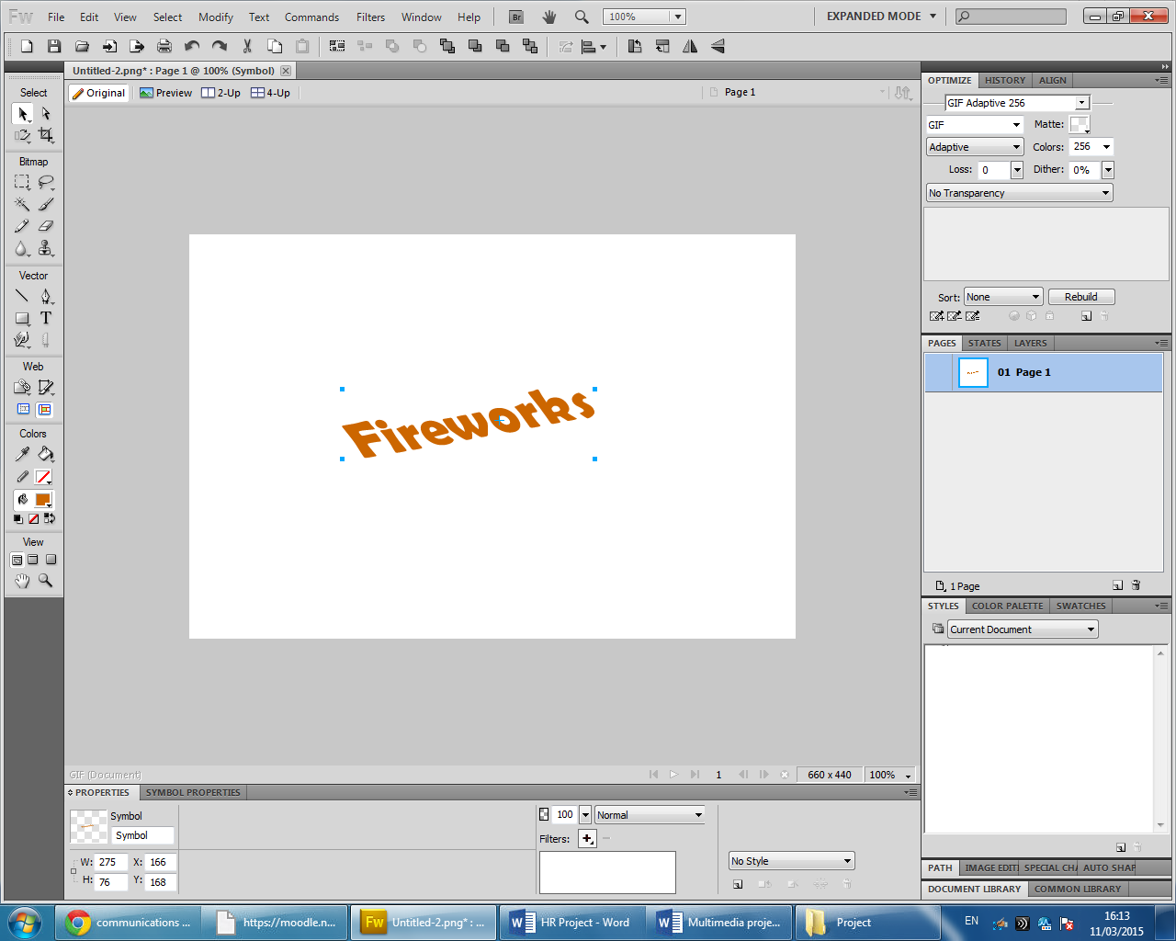

As you can see there are four main areas in Fireworks. On the far left is the **Toolbar**. This column contains categories of editing tools one can use on their document. These include the Bitmap, Vector, Colour, Web, View and Select tools. The area in the screenshot which I have labelled “Fireworks” in orange is called the **Main Document Window**. This area is used for layout of the documents. It is here where you will edit and create with all that Adobe Fireworks has to offer. If you look towards the bottom of the window above you will see another column called the **Properties Panel**. Here is where you can edit the properties of documents in a very user friendly way. Some of these being colour or position on the page, font and paint brush styles or the edging or texture on shapes. And finally, on the far right of the window are the **Panel Groups**. There are several elements to this section of Fireworks.

* Layers Panel: This panel enables the user to organise their document. It gives them the option to change, hide, lock, create and delete layers as the wish. Also included in the layers panel is the state panel. States are an animation tool that lets you see each stage of the animation. The user can also control the speed at which they move from state to state.
* History Panel: Keeps a record of the recent commands you have made in Fireworks so you can undo and redo them. But more importantly you can select actions you have made and save them for re-use as commands later on in the document.
* Document Library: Here the user can store imported documents in fireworks use later on in their documents development. This panel can be very useful when the user has a lot of images that need to be put onto the document for editing as they are available quick and easy.
* Special Characters and Auto-shapes: Essentially all that is contained in this panel is special charters such as “£”, “€” or “∑”. Auto-shapes are pre-set shapes and clip art style images that are in the Adobe Fireworks library such as stickmen, calenders, crescent moons and speechbubbles.
* Colour Palette: The user has a choice here of thousands of colours to enrich their document. The importance of colour and “*eye-catching”* graphics in today’s media is considerably higher than ever before.
* Align Panel: The align panel is a tool which aligns, distributes and matches the sizes of layers on the document accordingly to which alignment the user wants either relative to the object or canvas.

This short summary is only skimming the top of the depth of editing techniques Adobe Fireworks can provide. Compared to other graphic editors on the market it really does stand-out. Although it has other main rivals from its own Adobe family; Adobe Illustrator. There are a lot of industry professionals that prefer to use fireworks over Illustrator (or Photoshop) for web design purposes as Fireworks’ main attraction is its compatibility with vector *and* bitmap.

**Adobe Illustrator Cs5:**

Adobe Iluustrator was first developed for the Apple Macintosh in 1986 as a font development software. It was released on windows platform by 1997. Fast Forward to April 2010 Illustrator Cs5 was released in 2010 with new enhancements and features such as as perspective drawing tools, a bristle brush (a brush style that imitates real life strokes of a paintbrush) and more while maintaining a vector format. The main file formats for Illustrator is .AI and there a many more supported. Some of these include .PDF, .GIF, JPG similar to Fireworks. This programme is also widely used the graphic media and, like fireworks, it’s used a lot for web design and logos due to the fact that it uses a vector format. Vector formats are so crucial in modern Web design because they maintain the pixel quality in the image if it is adjusted or edited in any way while also having a very small file size. This enables web designers to use the many vector images in their website while not slowing the loading of the website down for its users.

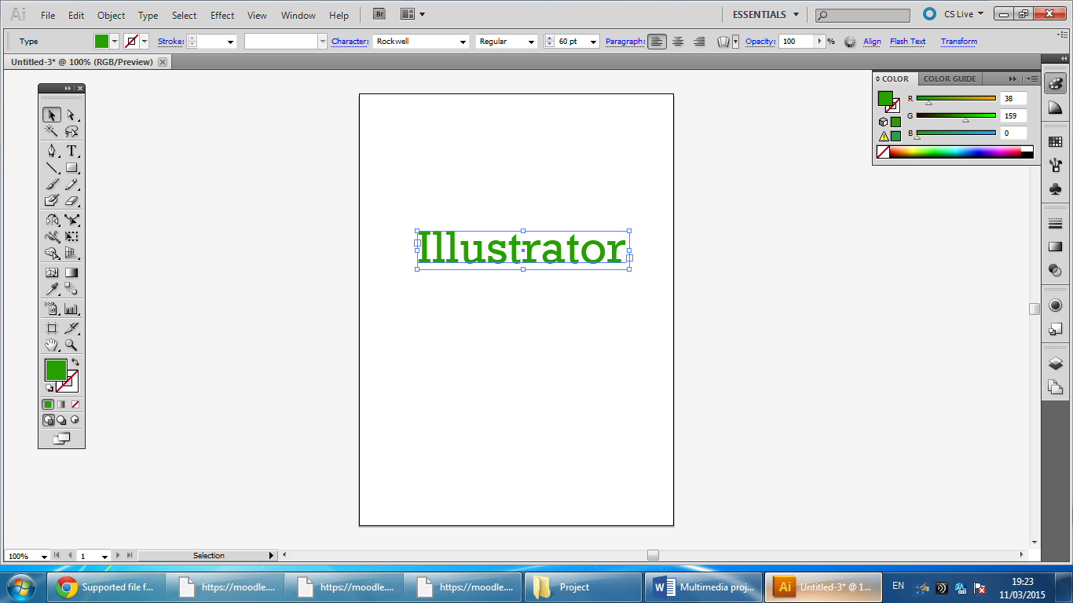

The interface for Illustrator as you can see is very similar to fireworks In its layout. Toolbars on the left, right and one on top this time.